**Case 2:**

**Figure 1: CMOS Inverter circuit with square wave input of 5V @ f = 300 kHz**

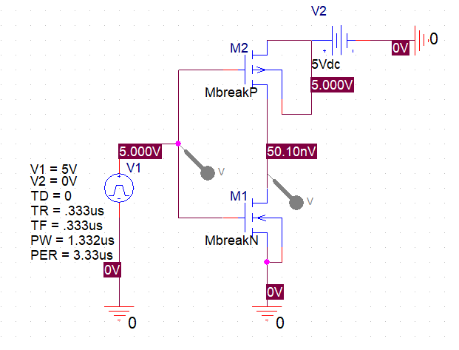

**Figure 2: I/O waveforms of CMOS inverter with input of 5V @ f = 300kHz**

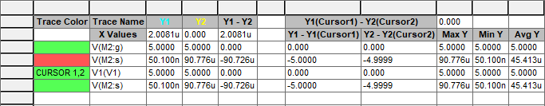

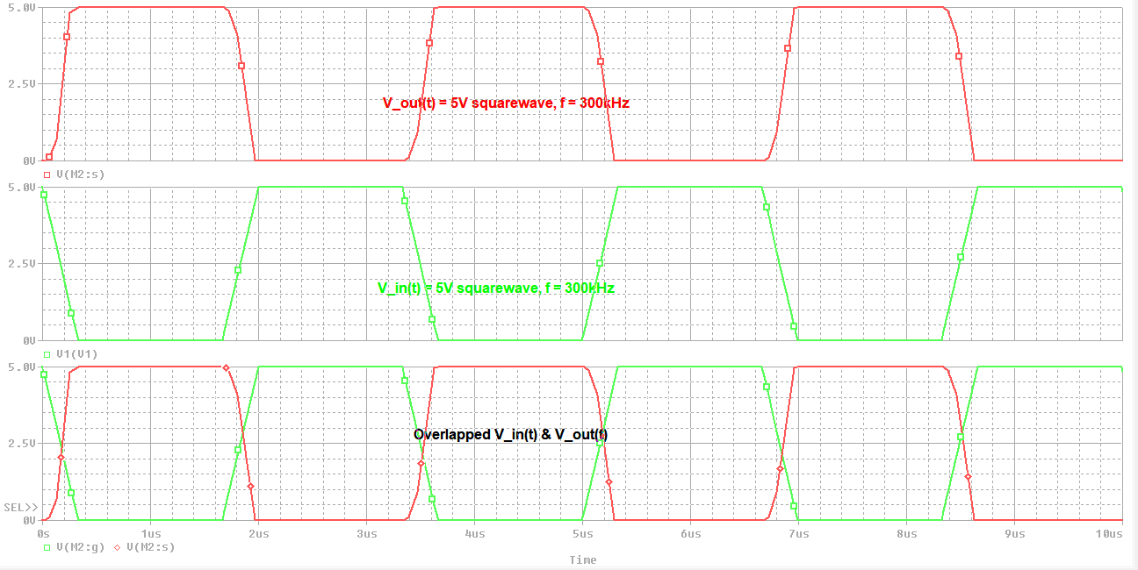

**Figure 3: ZOOMED I/O waveforms of CMOS inverter of propagation delay High-to-Low @ f = 300kHz**

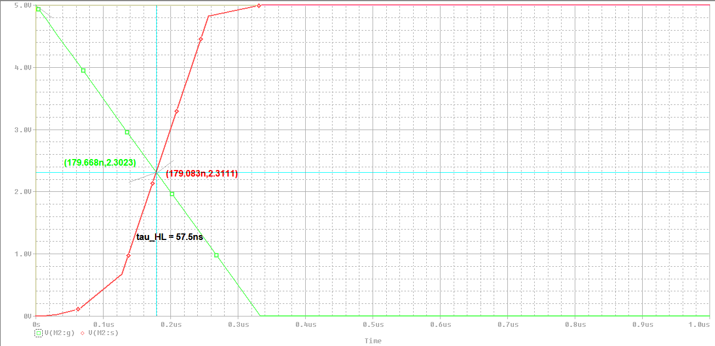

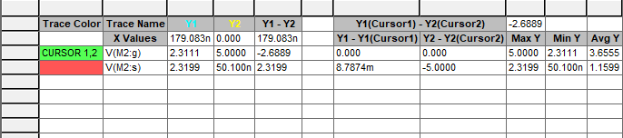

**Figure 4: ZOOMED I/O waveforms of CMOS inverter of propagation delay Low-to-High @ f = 300kHz**

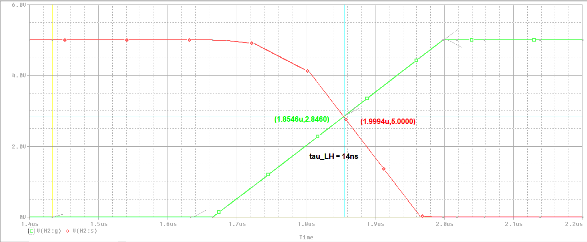

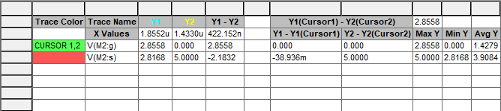

**Case 4:**

**Figure 5: CMOS Inverter circuit with square wave input of 5V @ f = 900 kHz**

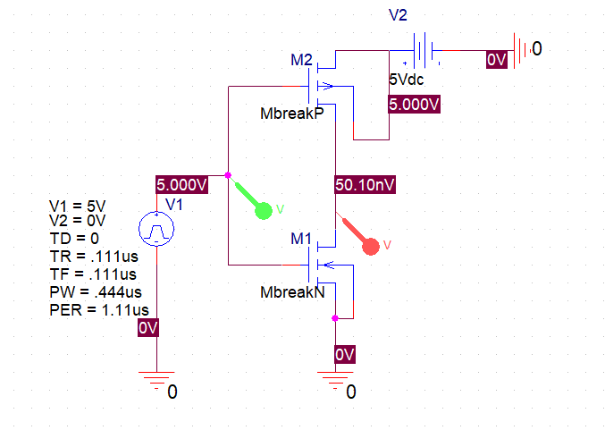

**Figure 6: I/O waveforms of CMOS inverter with input of 5V @ f = 900kHz**

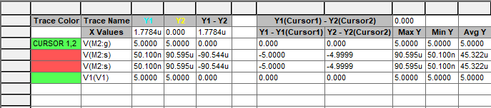

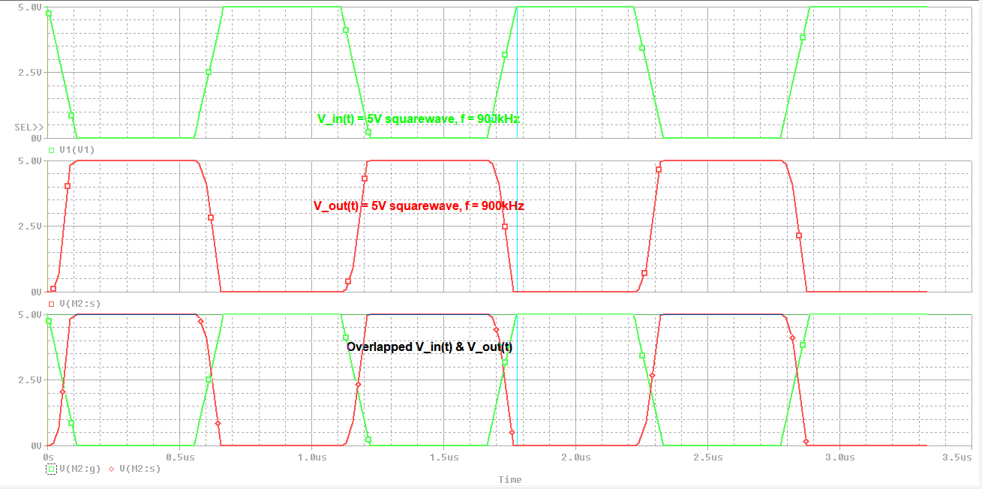

**Figure 7: ZOOMED I/O waveforms of CMOS inverter of propagation delay Low-to-High @ f = 900kHz**

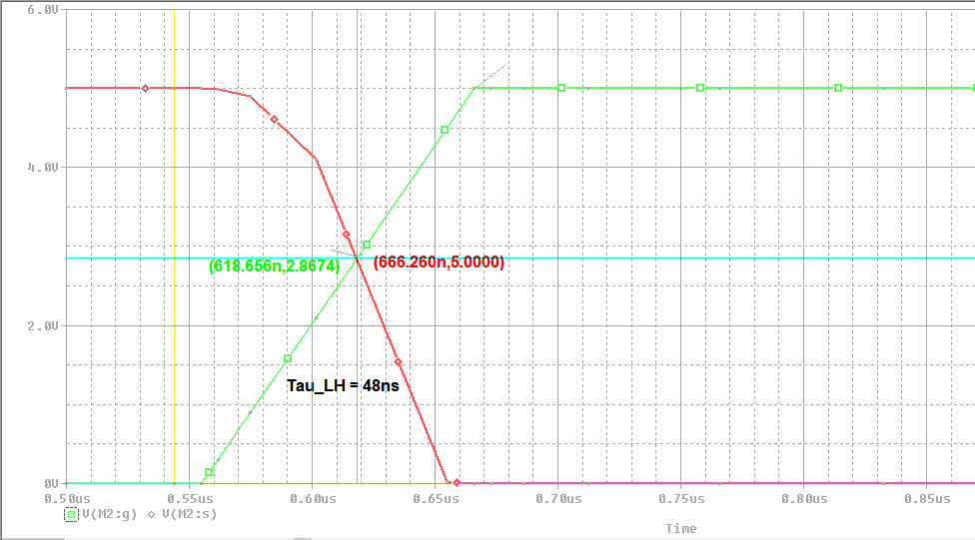

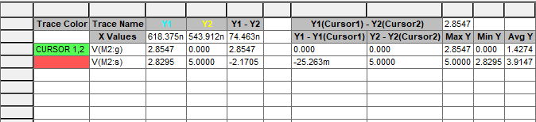

**Figure 8: ZOOMED I/O waveforms of CMOS inverter of propagation delay Low-to-High @ f = 900kHz**

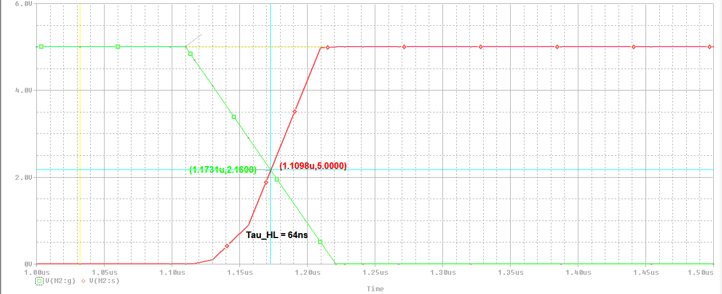

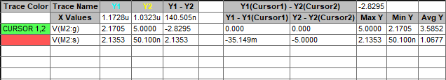

**Ramp case:**

**Figure 9: CMOS Inverter circuit with ramp wave input of 5V @ f = 200 kHz**

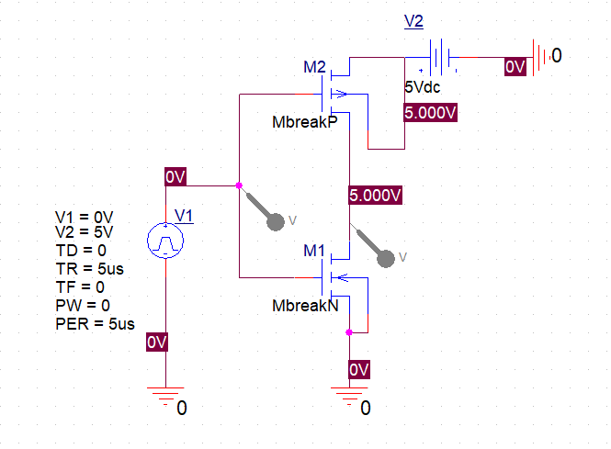

**Figure 10: I/O waveforms of CMOS inverter with input of 5V @ f = 200kHz**

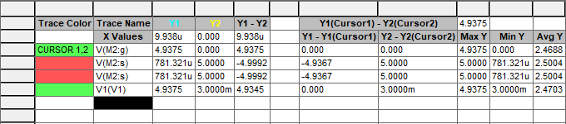

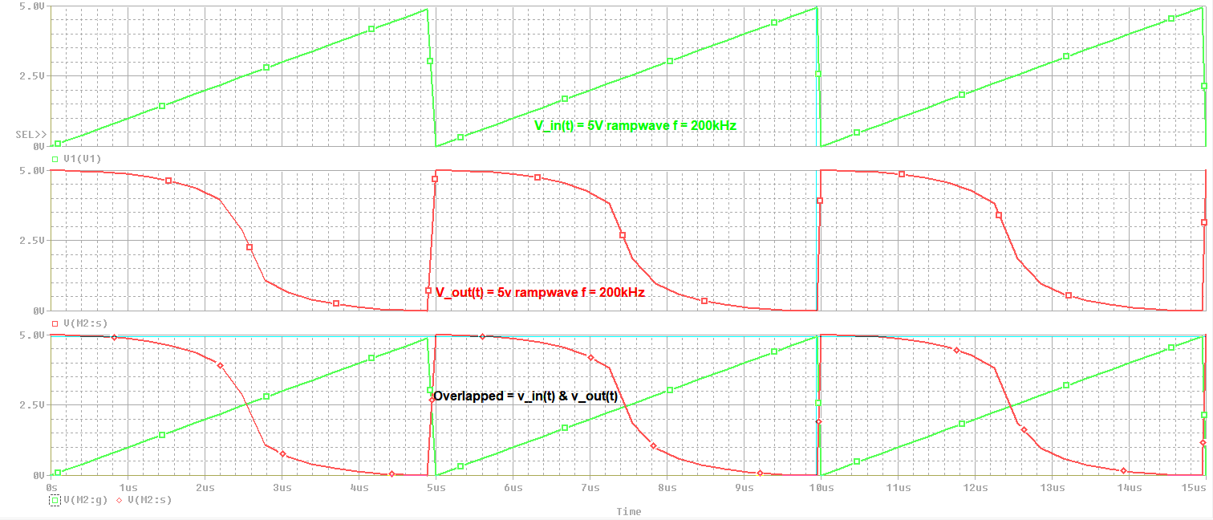

**Figure 11: ZOOMED I/O waveforms of CMOS inverter of propagation delay Low-to-High @ f = 200kHz**

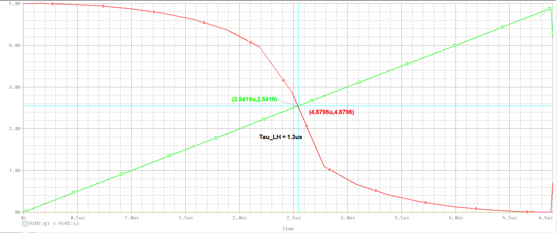

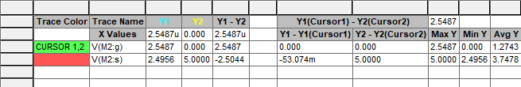

**Figure 12: ZOOMED I/O waveforms of CMOS inverter of propagation delay High-to-Low @ f = 200kHz**

